305-261/262 Measurement Laboratory
Experiment V

Stress and Strain

Introduction: strain-gauge system
Strain Gauges are transducers that experience a change of electric resistance when they are strained (deformed). The strain gauge is used in combination with other electrical components to obtain an electric voltage representing tensile, compressive or bending strain used to detect deformations or stresses.
Many varieties of strain gauges are available, but the most common devices rely on the principle that the change of resistance of a conductor depends on the change of its dimensions. A strain gauge consists of a tiny conducting wire of cross section A (m²), initial length L (m) and specific resistivity ρ (Ωm). The resistance R (Ω) of the wire changes when the wire is deformed (strained) by an external load (stress). The model that define the resistance R of the wire is:
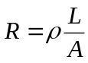 ……………………………………..(1)
In general, to describe the change of resistance of a strain gauge due to the change of length ΔL of the wire, a Gage Factor G is defined as follow:
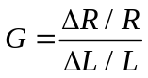 …………………………………(2)
where the ratio ΔL/L is the strain ε of the wire.
ε = ΔL/L (strain) is the change of length with respect to the original length. The unit of strain is in general mm/mm, or inch/inch but it is commonly expressed in microstrain με : 1 με = 10⁻⁶ mm/mm or in/in.
Therefore the Gage Factor G is a dimensionless quantity that expresses the ratio of the fractional change in resistance of the gauge to the fractional change in length (strain) along the axis of the gauge. The larger the value of G the more sensitive the strain gauge. It should be noted that the change of resistance with strain is not just due to dimensional changes in the conductor, but that the resistivity ρ of the material also changes with strain.
Transverse Sensitivity
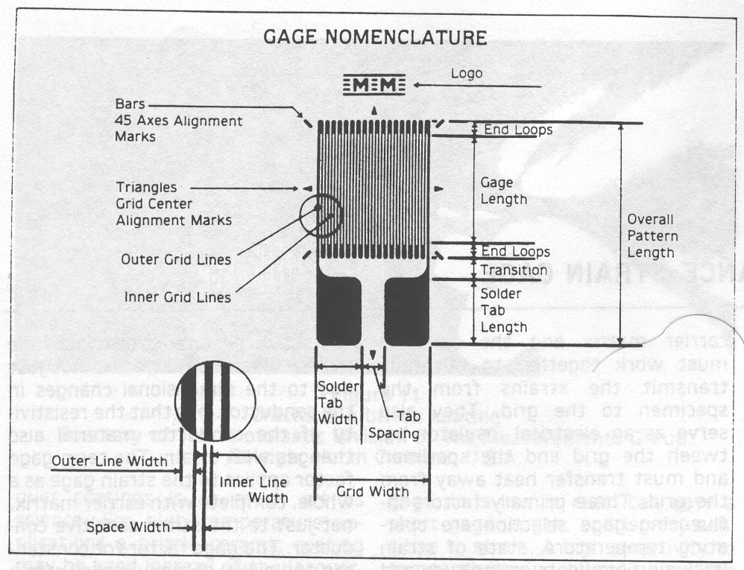
If the strain were a single straight length of conductor of small diameter with respect to its length, it would respond to strain along its longitudinal axis and be essentially insensitive to strain transverse (normal) to this axis. However, the conductor is in the form of a grid to reduce the effective gauge length and for this reason there are small amounts of strain sensitive material in the end-loops or turn-arounds that lie transverse to the gauge axis (Fig. 1). This end-loop material gives the gauge a non-zero sensitivity to strain in the transverse direction. Transverse sensitivity factor K_{t} is defined as :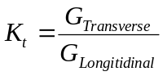 where G_{Transverse} is the sensitivity of the gauge to transverse strain while the G_{Longitudinal} is the axial sensitivity of the strain gauge to longitudinal deformation. Transverse sensitivity is usually expressed in percent with values that range from 0.1 to 10%.

Figure 1

Measurement of deformation using Strain Gauges
The Gage Factor equation shows that it is the fractional change in resistance the important quantity rather than the absolute change of resistance of the gauge. Lets see just how large this resistance change will be for a common strain gauge with G = 2 and nominal resistance of 120 Ω. The Gage Factor equation tells us that 1με (microstrain) applied to a gauge of resistance R produces a change of resistance:
ΔR = R∗1με∗G = 120Ω∗0.000001∗2 = 0.000240Ω
This means we need to have micro-ohm sensitivity (?!?) in the measuring instrumentation, and we also need to precisely measure the reference unstrained gauge resistance. In practice these difficulties are by-passed by the use of a different technique to measure small resistance changes with the use of the Wheatstone Bridge Circuit.

Wheatstone bridge circuit
The Wheatstone bridge circuit is one of the most frequently used circuits for static strain measurements because of its outstanding sensitivity. The working principle is illustrated in the following diagram.
A fixed regulated voltage V₀ is applied across nodes C and D of the bridge. The output voltage is measured across nodes A and B. Once the power supply V₀ of the circuit is fixed, the voltage output V_{OUT} is function of the resistance R₁, R₂, R₃, and R₄. The current I₀, coming from the power supply, reaches node C and splits into two parts I₁, and I₂. Current I₁ flows into the branch of R₁ in series with R₄, while current I₂ flows in the branch that consists of R₂ in series with R₃. Remember that two resistances are said to be connected in series where the same current flows through. Observe that currents I₁ and I₂ are not necessarily the same. Let’s calculate these two currents. Voltage V₀ is applied to nodes C and D, therefore the current in each branch will be inversely proportional to the resistance of each branch. This last sentence is mathematically written as:
V₀
I₂
I₀
I₁
A
B
C
D
R₁ R₂
R₄ R₃
V_{OUT}
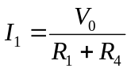 …………(3) 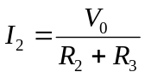……………(4)
We want to calculate the voltage output V_{OUT}. Following the diagram we see that the voltage output is the potential difference across nodes A and B. The voltage across A and B can be obtained following two paths: ACB or ADB. In other words, the voltage output can be calculated as:
V_{OUT} = V_{AB} = V_{AC} + V_{CB} ……………………………..(5)
or V_{OUT} = V_{AB} = V_{AD} + V_{DB} …………………………….(6)

Let’s follow the first path (5):
The voltage V_{AC} is the voltage drop across the resistance R₁ due to the current I₁, however this current goes from C to A indicating that node C is at higher potential than node A.
Therefore we have: V_{AC} = -I₁ R₁ ……………………………(7)

On the other hand when we calculate the voltage V_{CB} across nodes C an B we observe that it is the voltage drop across resistance R₂ due to the current I₂. Current I₂ flows from node C to node B indicating that node C is at higher potential than B.

Therefore we have: V_{CB} = I₂ R₂ ……………………………(8)

Finally we can calculate the voltage output by combining equations (5), (3), (4), (7), (8):
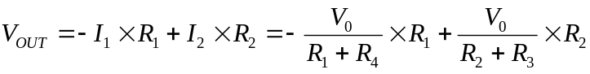
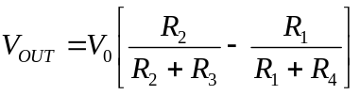 …………………..(9)

Observe that in equation (9), if all resistances are the same (R₁=R₂=R₃=R₄=R) then the voltage output is zero and the bridge is said to be balanced. Any small change of one or more of the four resistances will unbalance the bridge and the output voltage will not be zero but proportional to the change of resistance. For this reason the Wheatstone bridge is used to detect small resistance changes. Imagine you have four equal resistances one of which is actually a strain gauge. When the gauge is not strained by an external load, the bridge is balanced and the voltage output is zero. Any small strain of the gauge will determine a change of its resistance, which will result in a non-zero voltage output.
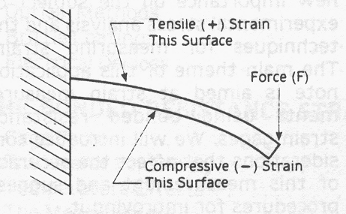
In order to improve the sensitivity of the bridge, more than one resistance can be substituted with strain gauges, however, in order to connect more than one strain gauge, the connection has to take into consideration the direction of the change of the resistance (increase or decrease). Strain can be either tensile (positive) or compressive (negative) as in the following example. The cantilever in bending illustrated in the following sketch undergoes tensile strain on the upper surface and compressive strain on the lower surface. A strain gauge glued on the upper surface will increase its resistance while an equal strain gauge symmetrically glued on the lower surface will reduce its resistance. When a load (force F) is applied at one end of the beam as in the sketch, the tensile stress σ along the x-axis of the upper surface is gives as:
σ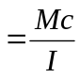 …………………………………………. (10)
where:
- M is the product of the effective length (m) of the beam times the load F (N) applied at the end of the beam.
- c (in this case) is half thickness (t) of the beam (m).
- I is the moment of inertia of the beam. In this case I = (bt³)/12.
- b is the width of the beam.
- t is the thickness of the beam.

Therefore the strain gauge system can be used to determine the deformation of the geometry of the beam. If a strain gauge of initial resistance R is glued on the upper surface of the beam, following the deformation its final resistance will be R+ΔR. Assume that this strain gauge is placed as R₄ of the Wheatstone bridge while all other resistances have value R. Substituting in equation (9) will give the following result:
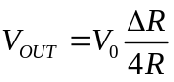 …………………………(11)

From equation (2) results G =(ΔR/R)/ε

therefore, ε = 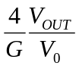 ………………………….(12)
If a second strain gauge is placed on the lower surface of the cantilever beam, the compressive stress will determine a decrement of the resistance ΔR so that the final resistance will result R-ΔR. If this strain gauge is placed as R₁ in the circuit of the Wheatstone bridge while R₄ is the strain gauge with final value R+ΔR, substituting in equation (9) will give:
ε = 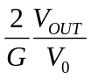 ………………………….(13)
indicating an increase of the sensitivity of the bridge circuit by a factor of two.

Experimental Investigation

Material Provided:

One Digital multimeter (DMM) to measure the output voltage of the bridge.
One Beam provided with two strain gauges glued on the upper and lower surfaces. Connecting wires are already soldered to the strain gauges. Handle this material with particular care. Strain gauges are extremely fragile! The value of the nominal resistance of these gauger is written on the beam.
One block to mount the beam in a cantilever beam configuration.
One support to apply the load to the cantilever beam.
A series of wheights to be used to load the cantilever beam.
One resistance. Between 25KΩ −35KΩ
Two resistances of the same value of the gauges (120 or 350Ω).
One 25KΩ precision potentiometer to balance the bridge.
One Breadboard to build the Wheatstone bridge circuit.
Connecting wires, stripper and screwdriver.
One power supply to provide the exiting voltage V₀ to the bridge. Attention! Use the 5V output voltage only!
One table of common material characteristic to find the Modulus of elasticity.
Measure Resistance to find which value you have.

Objectives:
- To use strain gauges to measure the deformation of a specimen.
- To build a Wheatstone bridge with balancing circuit.
- To use Hook’s law to determine the Modulus of elasticity of an unknown material.
Testing Procedure

The following Wheatstone bridge will be mounted on a breadboard. A of the connections of such board is given with these notes. The reason of using a balancing circuit is determined by the fact that it is practically impossible to find four perfectly equal resistances and the bridge would never be balanced. The Balancing circuit consists of a 27KΩ resistance and a 27KΩ precision potentiometer to be used to adjust the circuit and zero the output when the gages are unstrained. The connections of the potentiometer are marked 1,2,3 where three wires are already soldered to facilitate the connection to the bin board where the other resistances must be connected.
B
V₀
I₂
I₀
I₁
A
C
D
R₁ R₂
R₄ R₃
V_{OUT}
1
3
2
R₅
Potentiometer

- Measuer the actual dimension of the beam. The distance from the load application point to the center of the gauge.
- Mount the beam in the loading fixture so that the end of the beam is flush with the back of the block. Tighten the bolts.
- Connect the wires of the strain gauges to the connector placed on the stand of the block. The wires departing from such block will be used to connect the gauges to the rest of the circuit built on the breadboard.
- Mount the rest of the circuit paying attention at each connection. A sample setup is displayed in the Lab for your reference.
- Connect the output to the DMM and the input to the 5V power supply. Hang the load holder.
- After checking the circuit, turn on the power supply and try to zero the output using the potentiometer. You should be able to reach zero +/- few microVolt. If the offset is higher turn off the power supply and check the circuit.
- Write down the offset if you have a non zero output.
- Now prepare a table where you should write the loads applied to the beam and the corresponding reading of the voltage output.
- Use the following loads: 20g, 50g, 70g, 100g, 120g, 150g, 170g, 200g, 250g, 300g, 350g, and 400g. Place the loads slowly and carefully!
- For each load read and write the voltage output on your table.
- When you finish disconnect all components and measure precisely the voltage of the power supply.

Data reduction
- Using equation (13) calculate the strain of the beam for each load. You can do this using excel and inserting the formula. Do not forget to convert the mass load into Force.
- Calculate the stress for each case using Equation (10).
- Plot a strain versus stress graph using excel.
- Calculate the ratio of stress over strain for each case and obtain an average value.
- Compare this average (Young modulus or modulus of elasticity) value with the table on your desk and try to find the unknown material.
- Derive equation (13).

