Design Graphics – MECH 289

Assignments CAD6
Handed out March 27, 2006 Due April 3, 2006

For the drawing in Fig.1 of the part indicate all flaws and errors, which appear on it. Mark each one with a number and give a brief explanation, using a separate sheet of paper. Use template in Fig. 2 to provide the correct detailed drawing (with pencil and ruler).

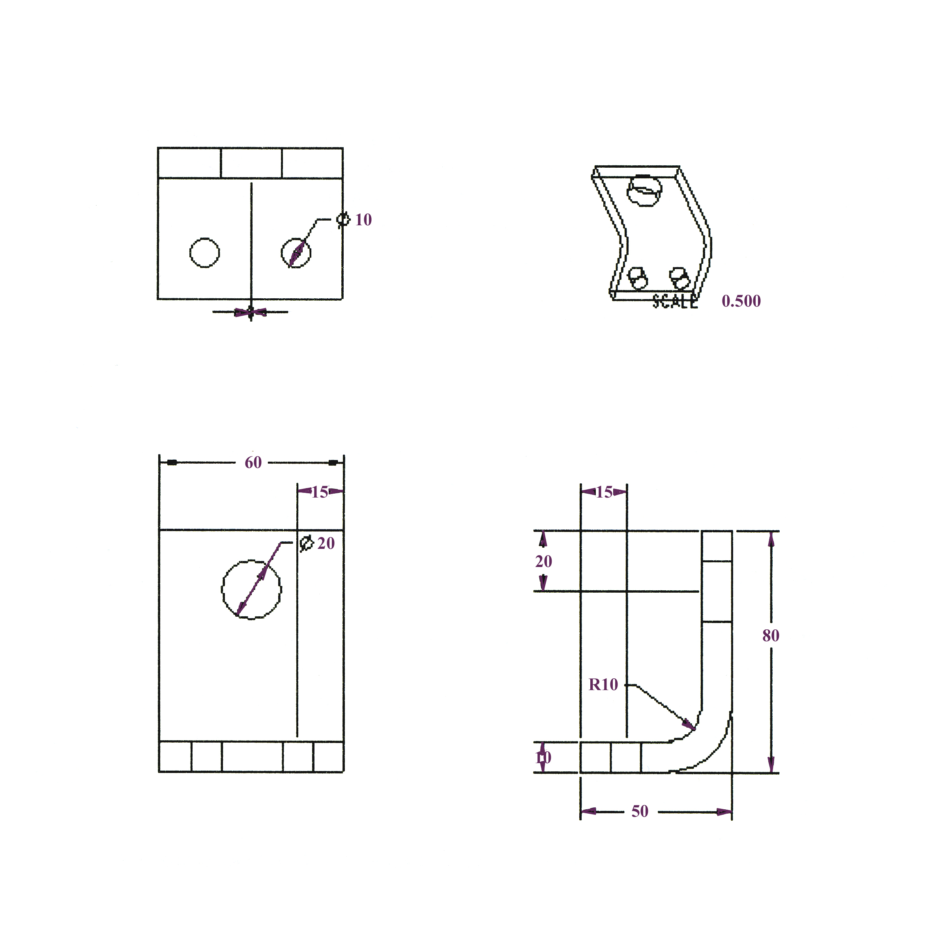
Fig.1
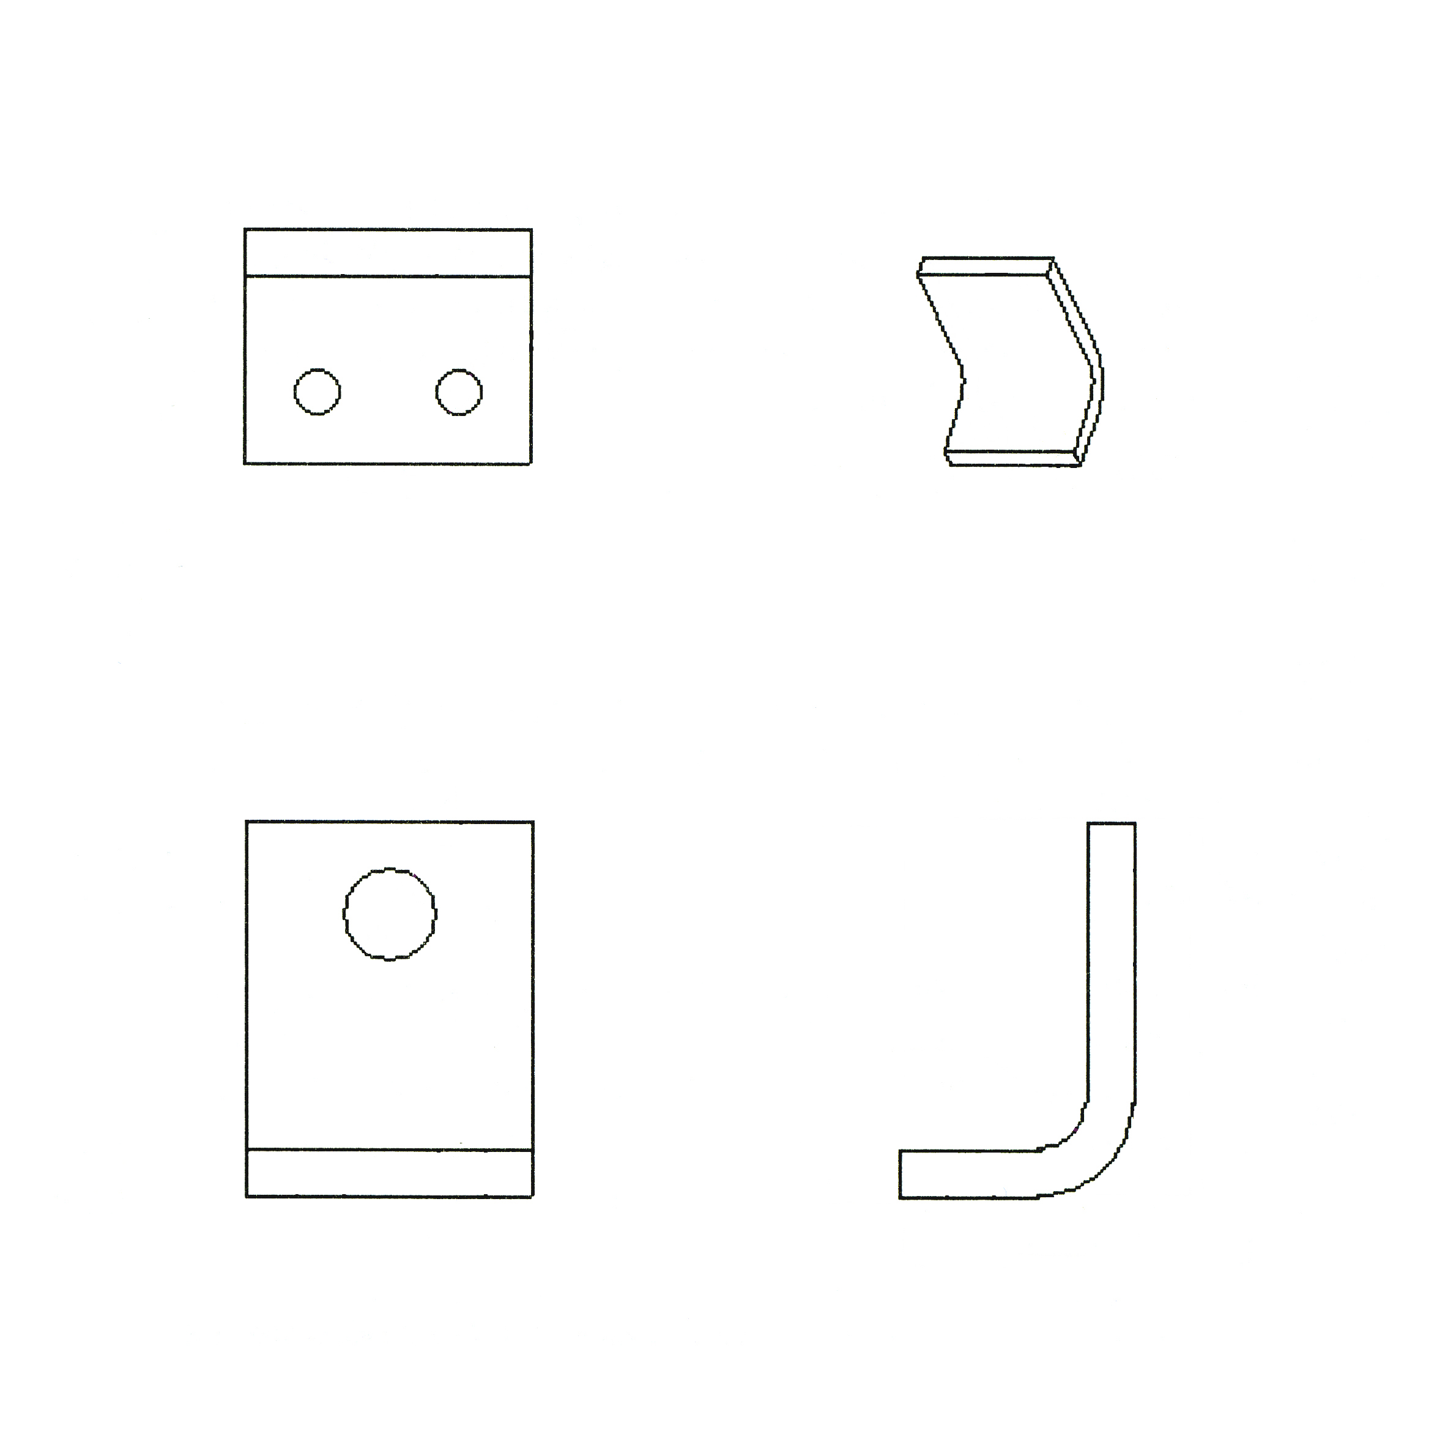
Fig.2

